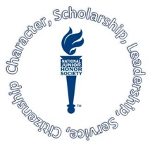
NATIONAL JUNIOR HONOR SOCIETY APPLICATION

Name: _______________________________ Student ID# ___________________
Grade Point Average (GPA) ______________ Grade ___________________
ELA Teacher __________________________
Hobbies and Interests:

Community Service Involvement and Activities:

Leadership Experience:

Teacher Recommendation and Comments:

Printed Name: ________________________ Signature: _____________________

On the back of this application, or on a paper separately typed, please describe yourself in 200 words or less, your strengths, and what you could bring to this academic, service club.

Please complete this application and return by Friday, September 13, 2019
Return application form to Mrs. Wierenga, Room 23-108 (Orange Hallway)

