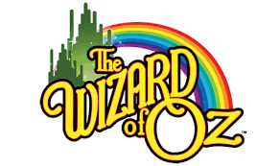
RIVER RIDGE MIDDLE/HIGH SCHOOL SUMMER DANCE CAMP
Come join us for a 4-day dance camp full of fun and excitement!!!
Monday, June 12 - Thursday, June 15
Ages 4-9 – Cost is $140.00 9:00-3:00pm
Ages 10 & up – Cost is $110.00 11:00-3:00pm
(There is a family discount)
***Early Bird Special if paid before May 1st***
Ages 4-9 - $125.00 Ages 10 & up - $100.00
Price includes a summer dance camp T-shirt
Dancers ages 4-9 will need to bring their own bag lunch each day and bottled water for camp. Snacks will be provided.
Dancers 10 and up will need to bring snacks and drinks with them for the day. There will be a performance for family and friends on the last day of camp, Thursday 15th @ 3:00.
To register and for more information please contact us at: Sara Taylor, at setaylor@pasco.k12.fl.us or Lynn Vairo at lvairo@pasco.k12.fl.us

